Uptown Modern

Web programming class project 2021/2022

|  |  |  |  |  |
| --- | --- | --- | --- | --- |
| Student Name in English | Student Name in Arabic | Student ID | Section | Work percentage |
| Sundos Saifi | سندس مصطفى صيفي | 11924204 | 8-9.5 احد-اربعاء | 33.3% |
| Yaqeen Yaseen | يقين محمد ياسين | 11924311 | 8-9.5 احد-اربعاء | 33.3% |
| Abdullah refai | عبد الله منذررفاعي | 11923491 | 8-9.5 احد-اربعاء | 33.3% |

Date/time

---------------------------------------------This section is intended for the Instructor---------------------------------------

|  |  |
| --- | --- |
| **Topic** | **Mark** |
| Project Idea |  |
| Project Complexity |  |
| Project Tools |  |
| Project Requirements and Modeling |  |
| Project Discussion |  |
| Project Completeness |  |
| Project Output Results or reporting |  |
| Project Administration and Management |  |
| Project Report |  |
| Team work |  |
|  |  |
|  |  |
|  |  |
|  |  |
|  |  |

Table of Contents

Project Abstract: 3

Introduction: 3

A:User: 3

B:Admin: 3

Project Requirements: 4

The Used Tools: 5

Our DataBase: 6

A:Uml 6

B:Tabels Structure 7

Project Explanation: 9

USER: 9

A: Site layout when logging in as a user: 9

B: GUI when logging in as user: 9

1:Home:………………………………………………………………………………………………………………………………………………………………………10

2:Our Story:………………………………………………………………………………………………………………………………………………………………..16

3:Store:………………………………………………………………………………………………………………………………..…………………………………….18

4:Product:………………………………………………………………………………………………………………………………………………………………..…19

5:Login:…………………………………………………………………………………………………………………..…………………………………………….……20

6:Reset Password:…………………..……………………………………………………………………………..………………………………………………..…21

7:Signup:………………………………………………………………………………………………………………..………………………………………………..…21

8:Profile page :………………………………………..……………………………………………………………..…………………………………………….……22

9:Orders page :………………………………………..……..……………………………………………………..…………………………………………………..23

10:Cart :……………………………………………………..……..…………………………………………………..………………………………………………..…23

11:Payment with PayPal :……………………………………………………..……..………………………………………………………………………….…24

12:Search page :……………………………………………………..……..……………………………………………………………………………………….…25

13:Blog page :……………………………………………………..……..……………………………………………….………………………………………….…26

14:Article page :……………………………………………………..……..…………………………………………………………………………………….……27

14:Contact Us page :……………………………………………..……..……………………………………………………………………………………….…28

14:Log Out :……………………………………………………..……..……………………………………………….…………………………………………….…29

Admin: 30

A: Site layout when logging in as a Admin: 30

B: GUI when logging in as Admin: 30

conclusion: 35

Refrences: 36

**Project Abstract:**

Uptown Modern is an online store in Palestine specialized in selling new and used furniture. The site came to make it easier for the user to buy furniture without the need to visit our showroom. Many users prefer online shopping because of life's preoccupations so we came to the rescue.

**Introduction:**

We have designed our website which specializes in selling modern furniture and home furnishing supplies such as decorations and antiques, which allows the user to purchase products and add them to the shopping cart, And facilitating the process of entering data about furniture and modifying it for those responsible for the site.

-Here I will explain in particular what our site makes available to both the user and the admin

* User: When you enter the site as a user, we have provided you with the ability to see everything the site offers without the need to log in. You can see what we provide of furniture and decorations, but if you decide to add something to the shopping cart, you must log in or create an account on the site if you do not already have an account and then log in and add the product to the shopping cart.
* Admin: The admin is the one who controls the additions and modifications that are made to the user’s screens and appear to him. The admin has the powers to add new products and delete products, and he has the ability to add furniture categories of colors, materials and brands, and he can ban a user from the site, he also tracks requests until they arrive and determines which of them are canceled, and adds articles about Furniture and controls the Instagram posts,and It also sends news letter emails to registered users.

**Project Requirements:**

-Uptown Modern is a Website to sell modern furniture in palestine.

The system is organized into: -

1-Users consists of ID(unique), first name,last name ,phone number, city ,address ,email ,password and active status.each user will be able to order a furnitures, read an article in blog section and subscribe in a newsletter(not compulsory to be an registered user).

2-Product consists of ID(unique),name,price,sale status,amount,number of sales,category,available status,short description,long description,manufacturer,dimensions,weight,require assembly status,color,brand,material and pictures.

3-Color consists of ID(unique) and color hex value.

4-Material consists of ID(unique) and Name.

5-Brand consists of ID(unique) and Name.

6-Sale consists of ID(unique) ,Product ID and sale price.

7-Product images consists of ID(unique) ,Product ID and path of the image.

8-Instagram posts consists of ID(unique) and url of the post.

9-Newsletter consists of ID(unique) and email of the subscriber.

10-Admin consists of ID(unique), first name, last name, picture, bio, email, password. Each admin can write an articles for the blog section.

11-Article consists of ID(unique), title, post date, category, pic, content and author id, each article has one author(admin who write articles).

12-shopping consists of ID(unique), user id, product id,amount and total price.

13-orders consists of ID(unique), user id, product id,order date,amount,price and state.

**The Used Tools:**

We implemented the website using:

* HTML5.
* CSS3.
* SQL.
* JAVASCRIPT.
* PHP.
* we used as port xampp as localhost.
* phpMyAdmin as data base manager.
* VSCode as an IDE.
* For fonts we used google fonts.
* For some icons we used font awesome.
* phpMailer for sending emails.
* we integrate things such as paypal payment gateway,social media share buttons to share posts and products on facebook and twitter,and google maps to share our location.
* Draw.io for drawing UML

**Our DataBase:**

A:Uml

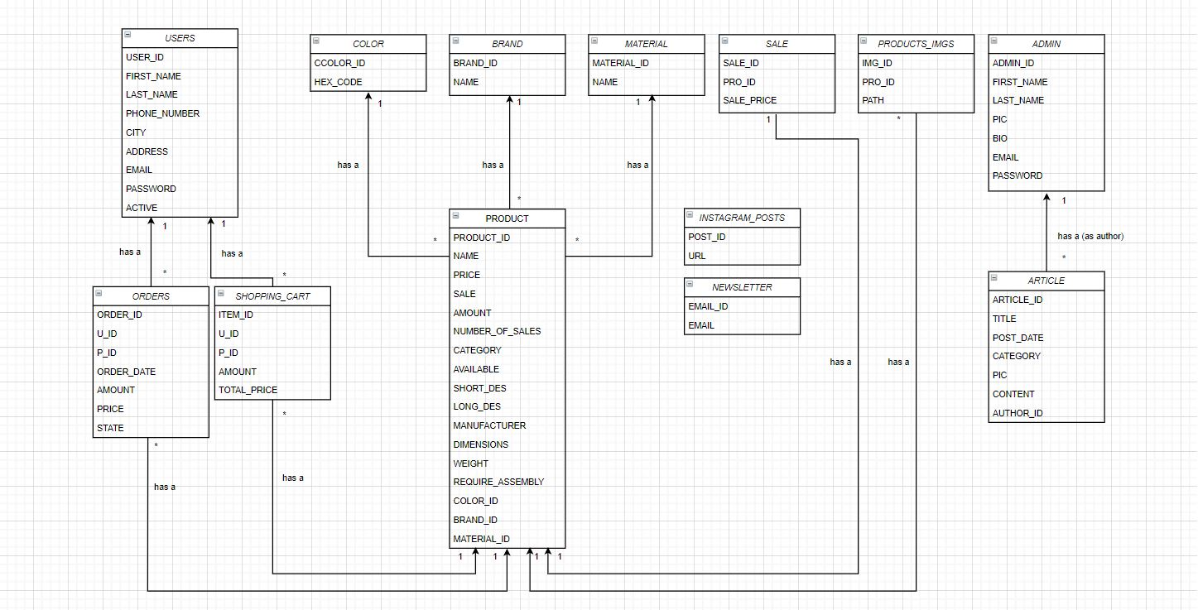

B:Tabels Structure

1-Admin table

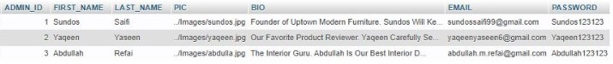

2-Article Table

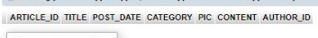

3-brand table

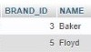

4-color table

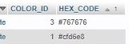

5-instagram_posts table

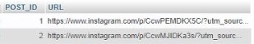

6-Material table

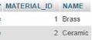

7-newsletter table

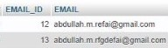

8-Orders table

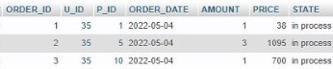

9-products table

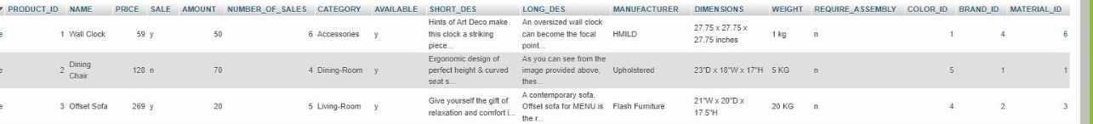

10-products_imgs table

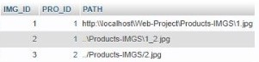

11-sale table

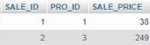

12-shopping_cart table



13-users table



**Project Explanation:**

USER:

A:Layout when logging in as a user:

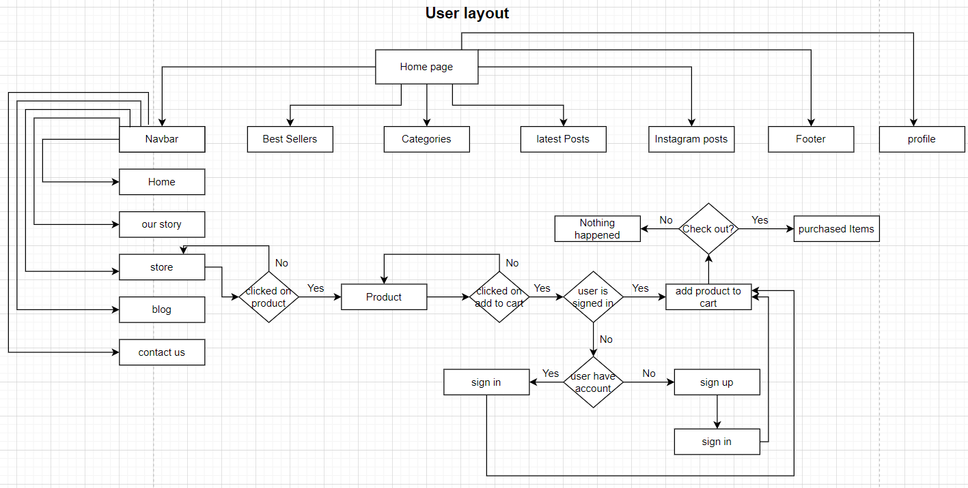

B:GUI when logging in as a user:

1-Initially, as soon as the user enters the site, this screen will appear, which is characterized by the presence of animation (the chair moves with the movement of the mouse and its direction) and there is a button when pressed we go to the store page, specifically the brand category of our store (the future) .In the navbar there is the burger menu to the left which show us the side nav bar and on the right the user finds the shopping cart, profile button, search button these are found in all screens,at last in the middle of the nav there is the site icon, which when we click on it takes us back to the home page.

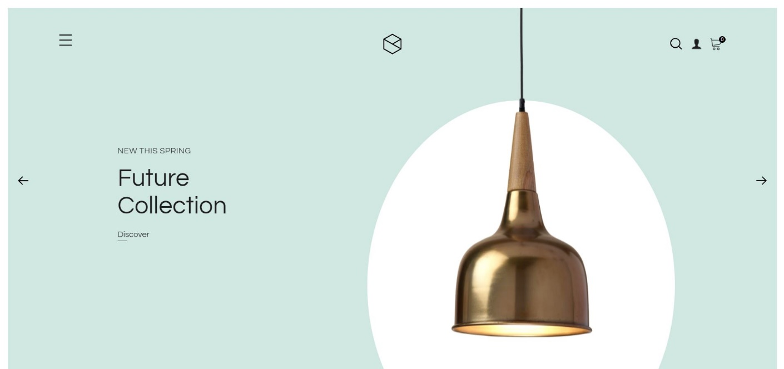

2- After that you will find notes about our policy in payment, return and shipping, and also this window is characterized by the presence of animation that moves from left to right

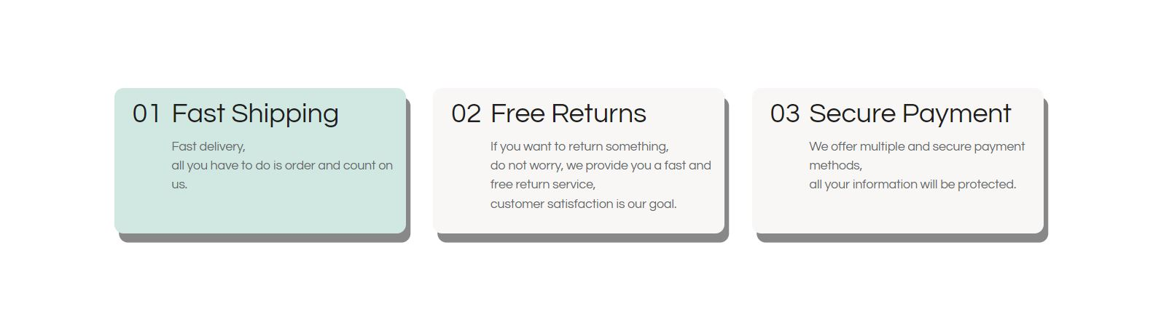

3-Then we show you the best-selling products in our store and when you choose a product, you go to the product screen in which we display detailed information about the product and you can add it to the shopping cart from there.

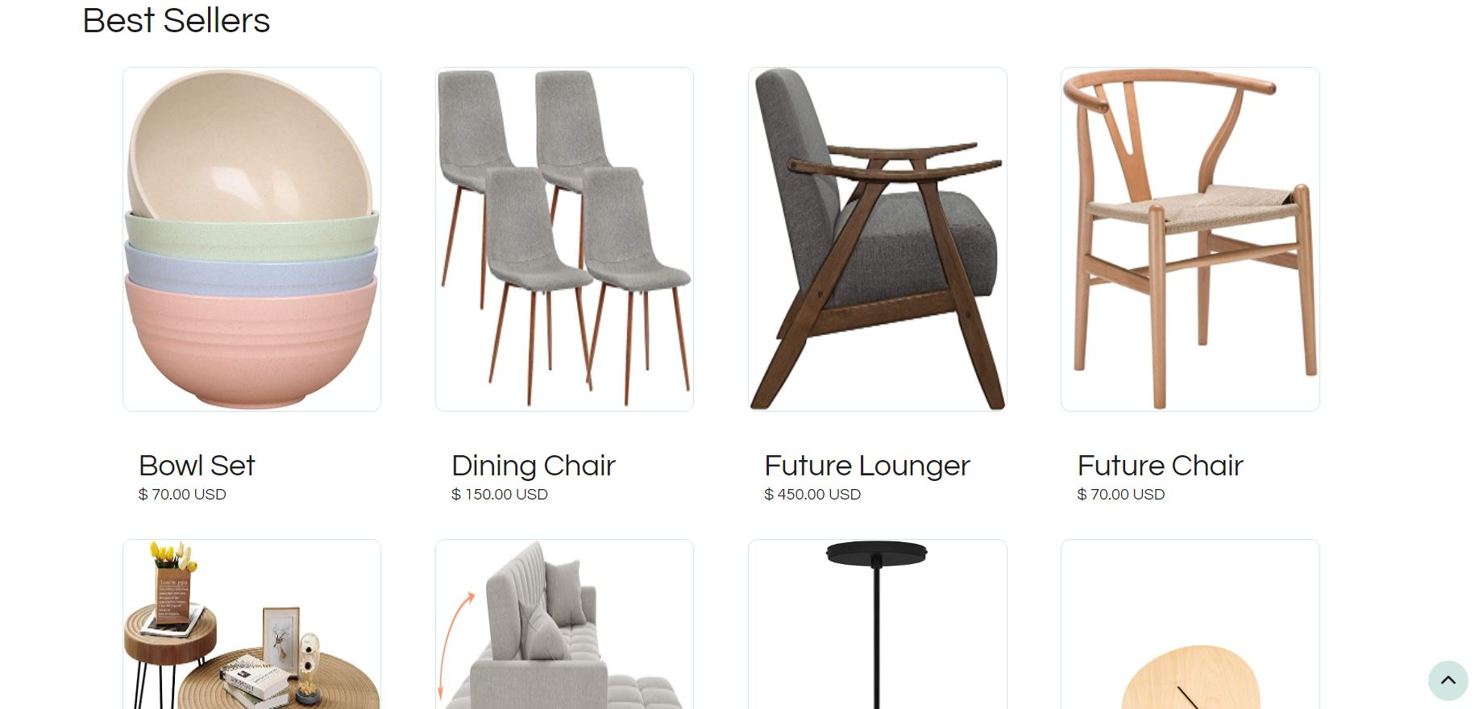

4- After that, we show the user all the categories of furniture available on our site, and there is a view category button , which takes the user to the store screen, specifically the chosen category. This screen is characterized by the presence of animation that moves the residential rectangle with the movement of the scroll up and down.

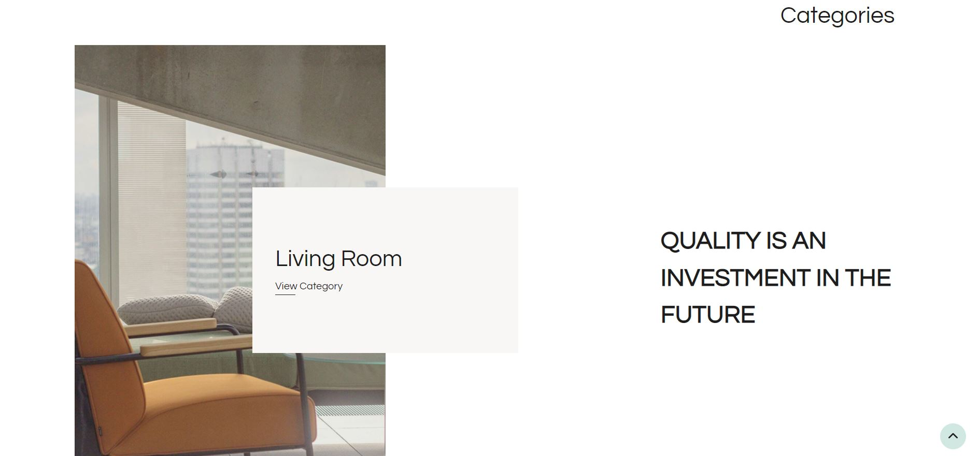

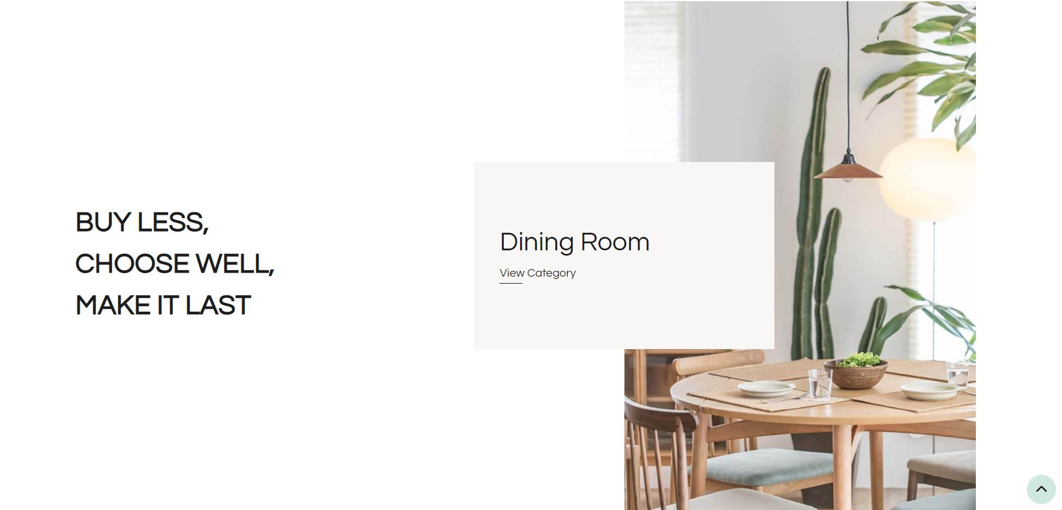

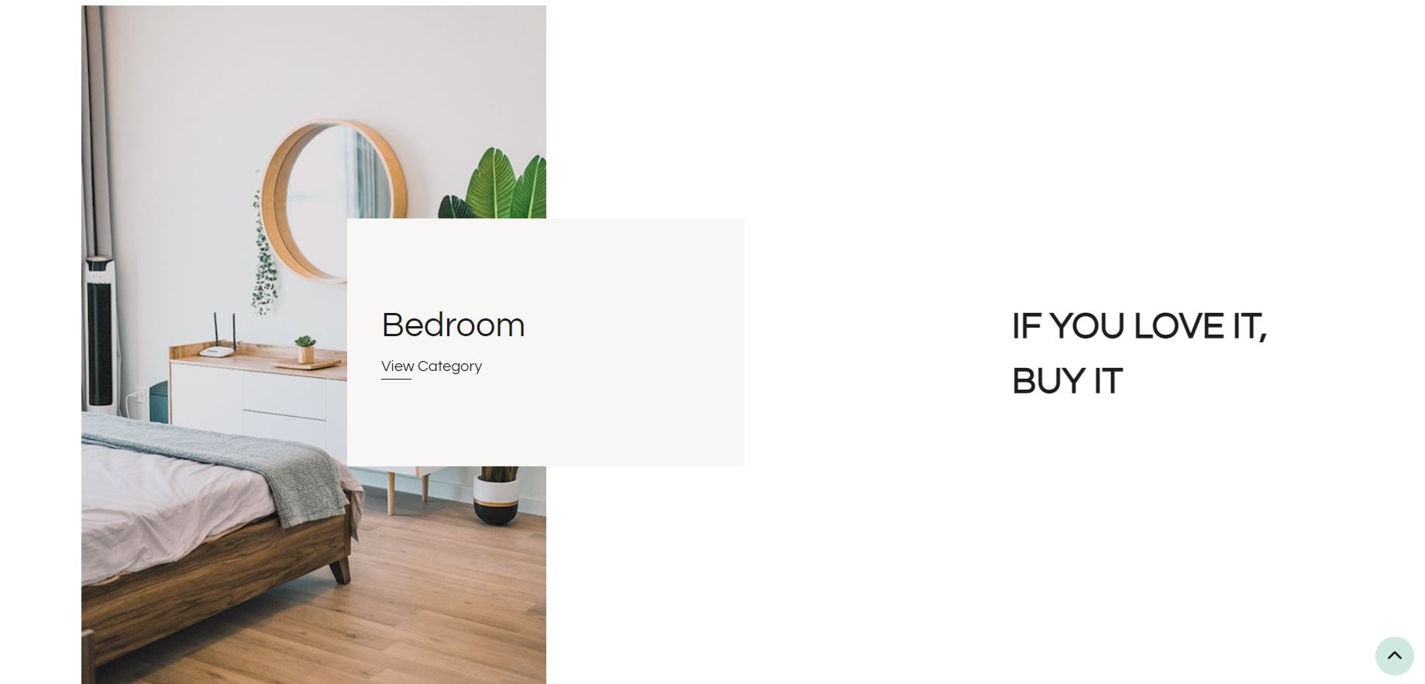

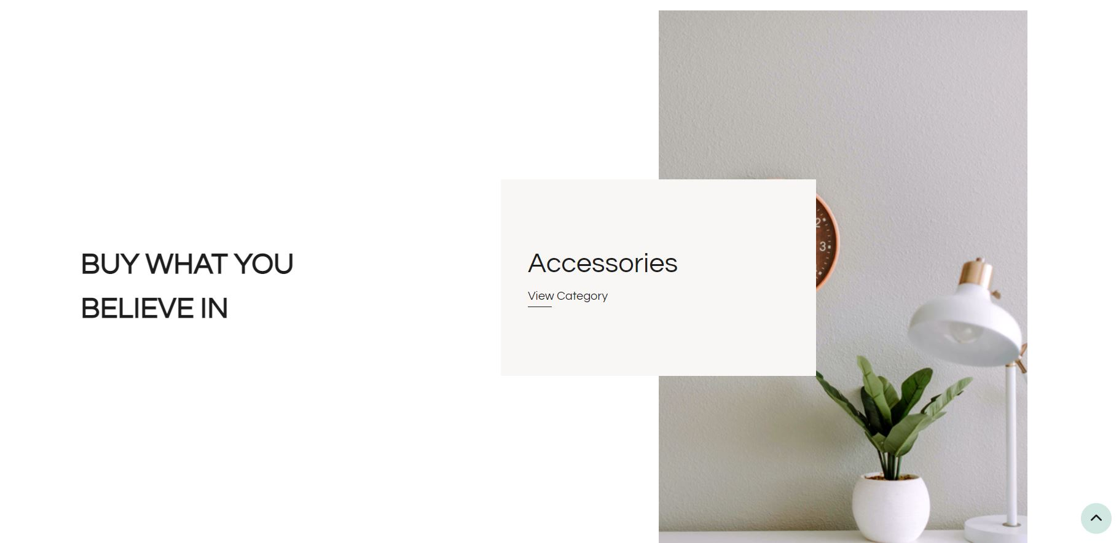

5- After that, a banner appears, inviting the user to visit the store page and enjoy seeing high-quality furniture and shopping from it



6- After that, the screen of the latest posts appears, through which we can show the user the latest articles we wrote about furniture, tips or trends.

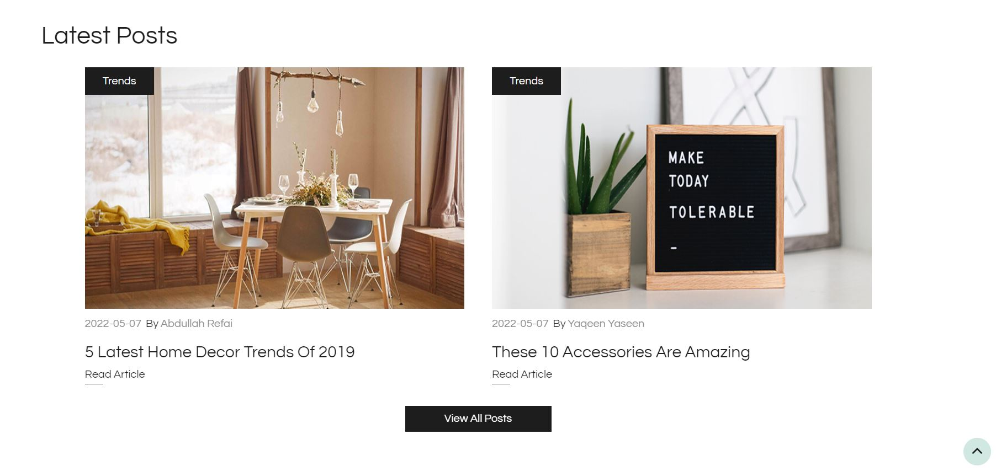

7- There is no doubt that social media today dominates the best ways of marketing and we do not neglect this matter, so we care about our pages on various sites, especially Instagram. Here we show our latest posts on Instagram, which when you click on one of the posts will take you to the post on Instagram, and here the animation appears on the left when the mouse touches the image.

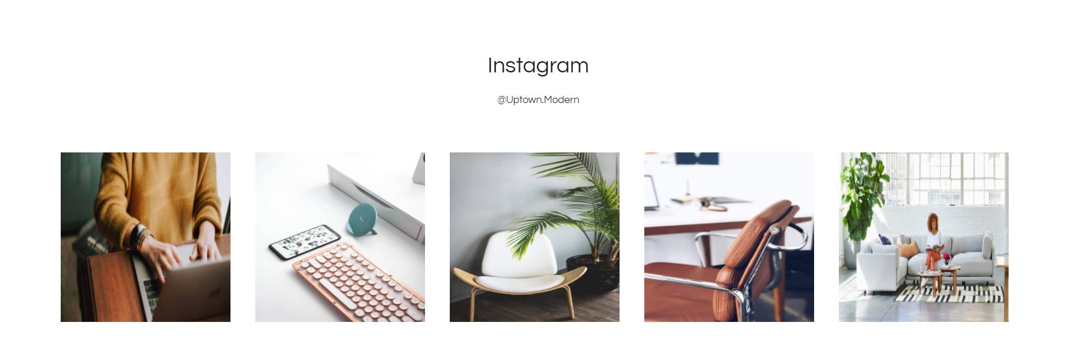

8- Here, the footer will appear, which will remain with us on all screens on the site,in the footer any visitor to the site , can subscribe to a service(newsletter)

In this service we send letters to the subscribers emails about latest products ,sales and blogs.

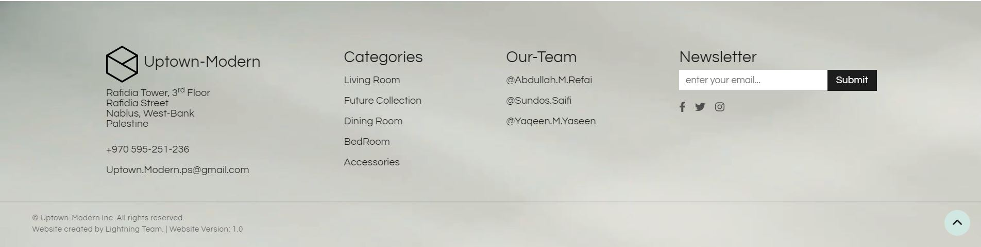

9- When you click on the burger menu that appeared in the first picture above, the side nav bar appears, through which we move between the different parts of the site.

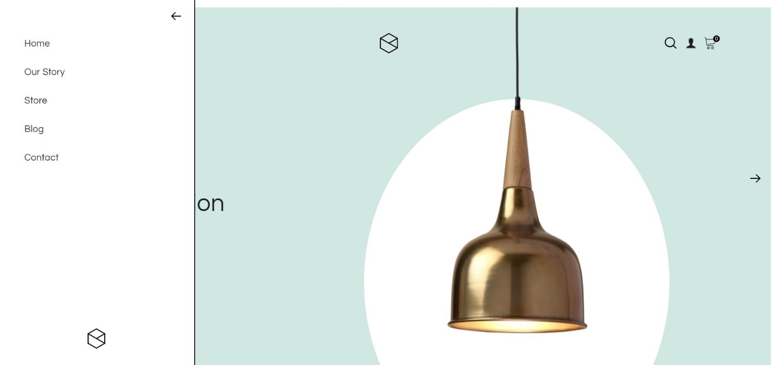

10- When you click on our story button, the nav bar that we talked about previously appears, and then our story appears, we talked about the beginning of the project and how it all started.

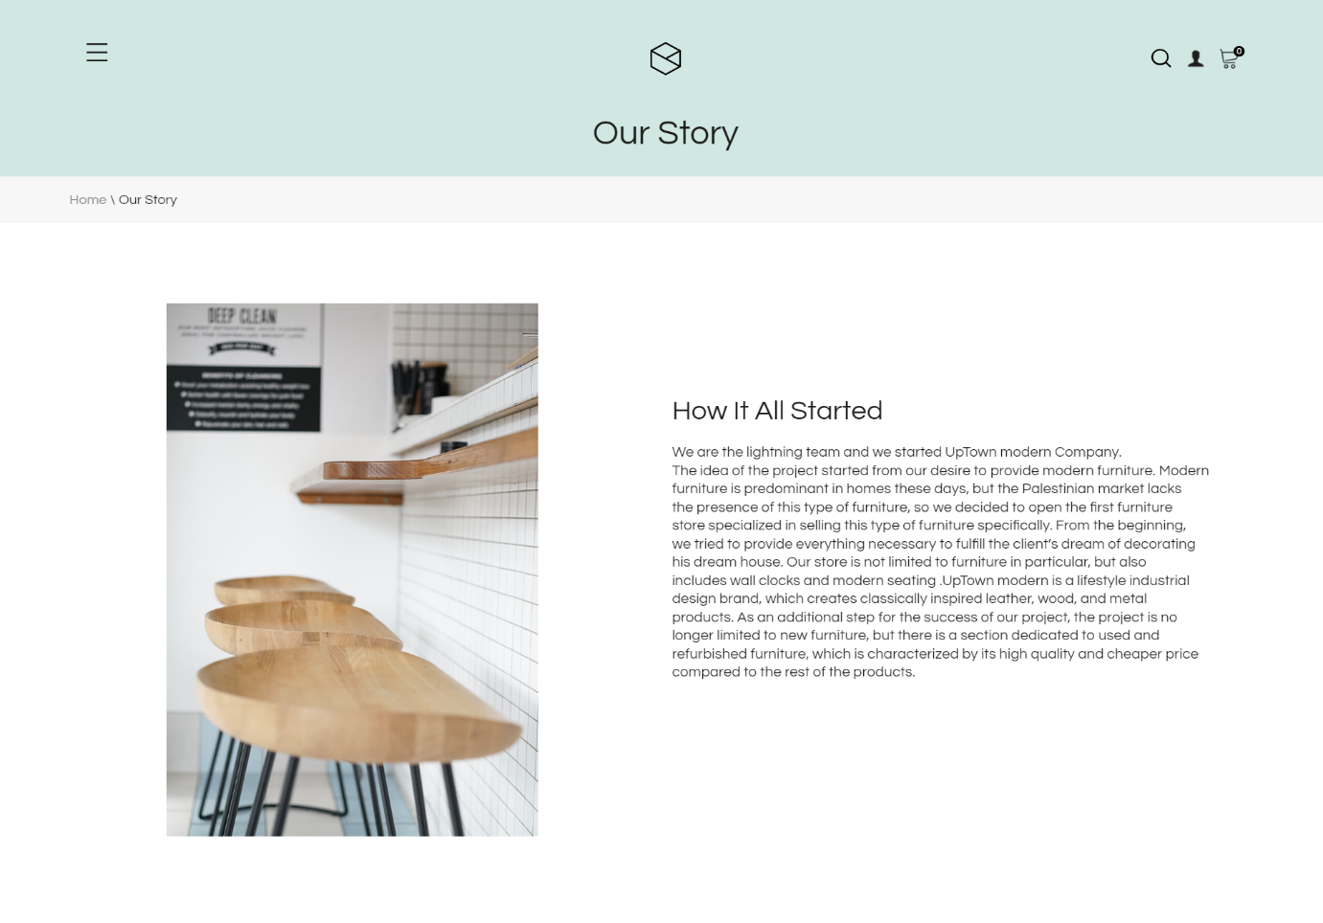

11-After that this beautiful animation will appear (the commas go up and down and rotates with the movement of the scroll bar)

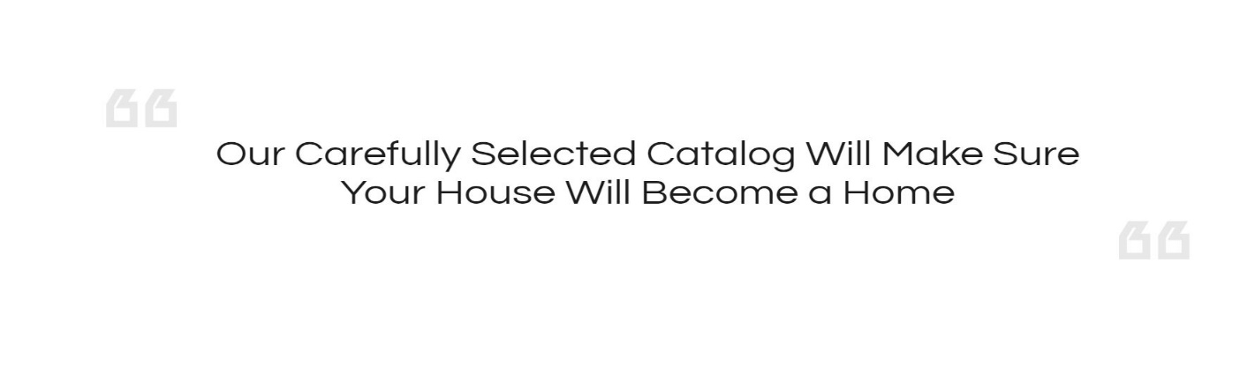

12-after that we talked about our newest feature which is hand crafted masterpieces and we introduced the user to the team that is responsible of all this work.

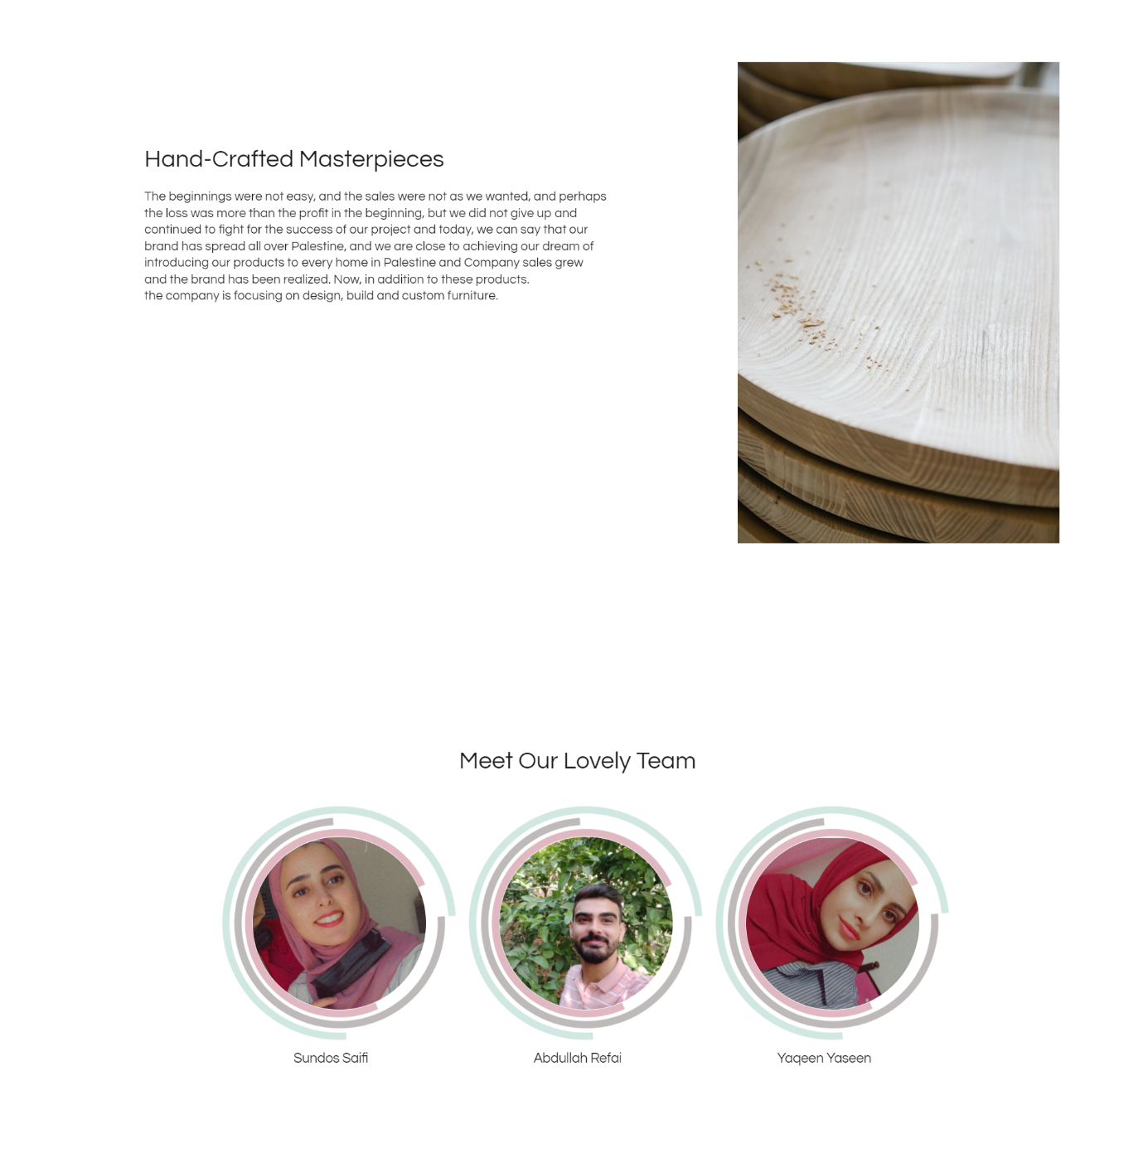

13- If we click on the store page, the following screen will appear, as it is clear, at first the nav bar appears at the top of the page, and at first it displays all the available furniture without its classification, and several categories appear on the left of the page through which we can sort the furniture according to the classification we want, such as the color, brand ,nature of the furniture, the material it is made of and finally the price.

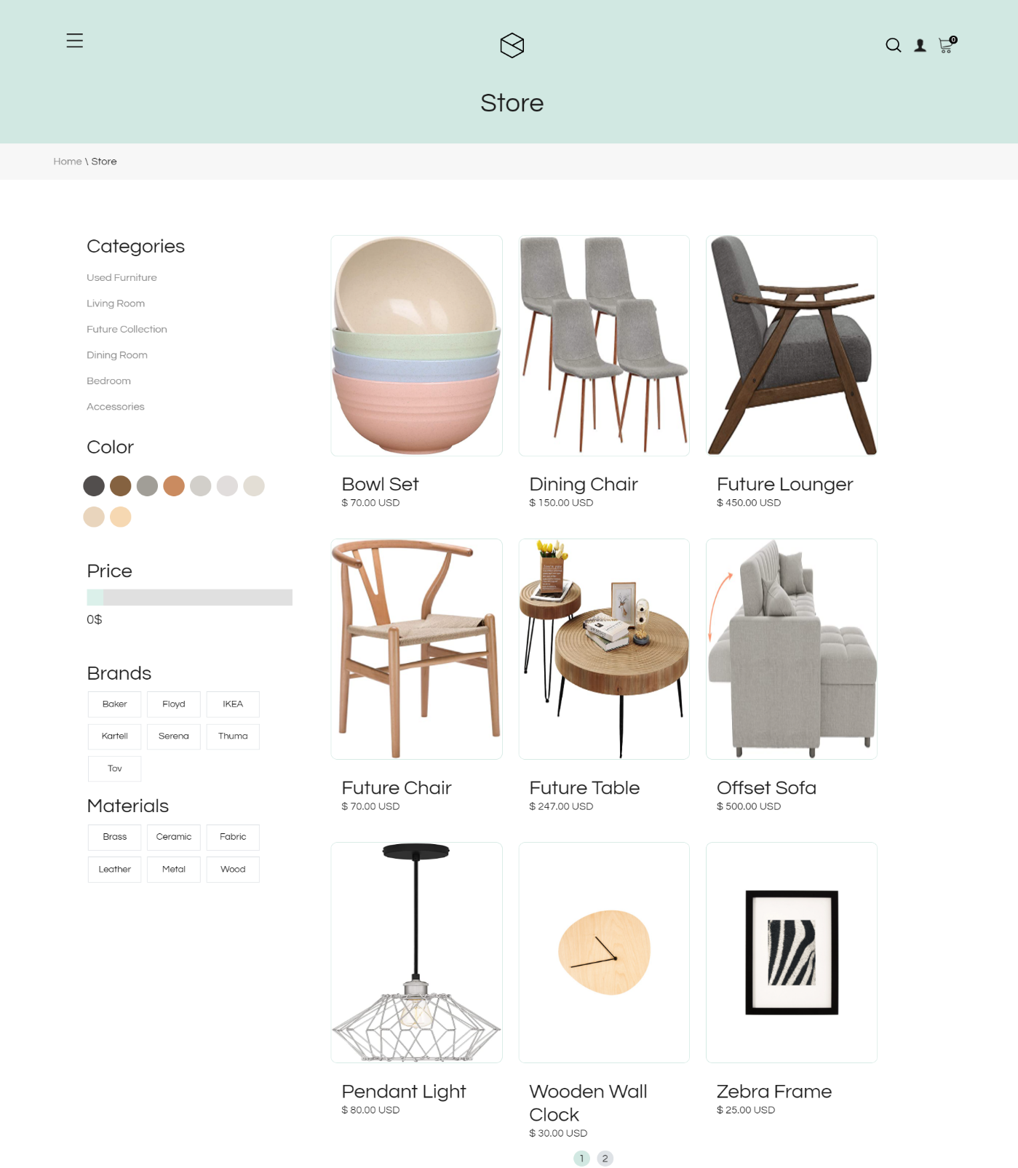

14- If you want to order a product, all you have to do is to click on the product on the store page, and then you will be sent to the product page which appears below on this page, we show the user all the information he needs about the product, starting from the price of the product, a description about the product and several pictures of the product from different angles. We have also allocated a box below the product image to display additional information and a description of the product.Due to our believe in the importance of social media in marketing , And we want to give the user the opportunity to share our products we added two buttons to share products either on facebook or twitter.

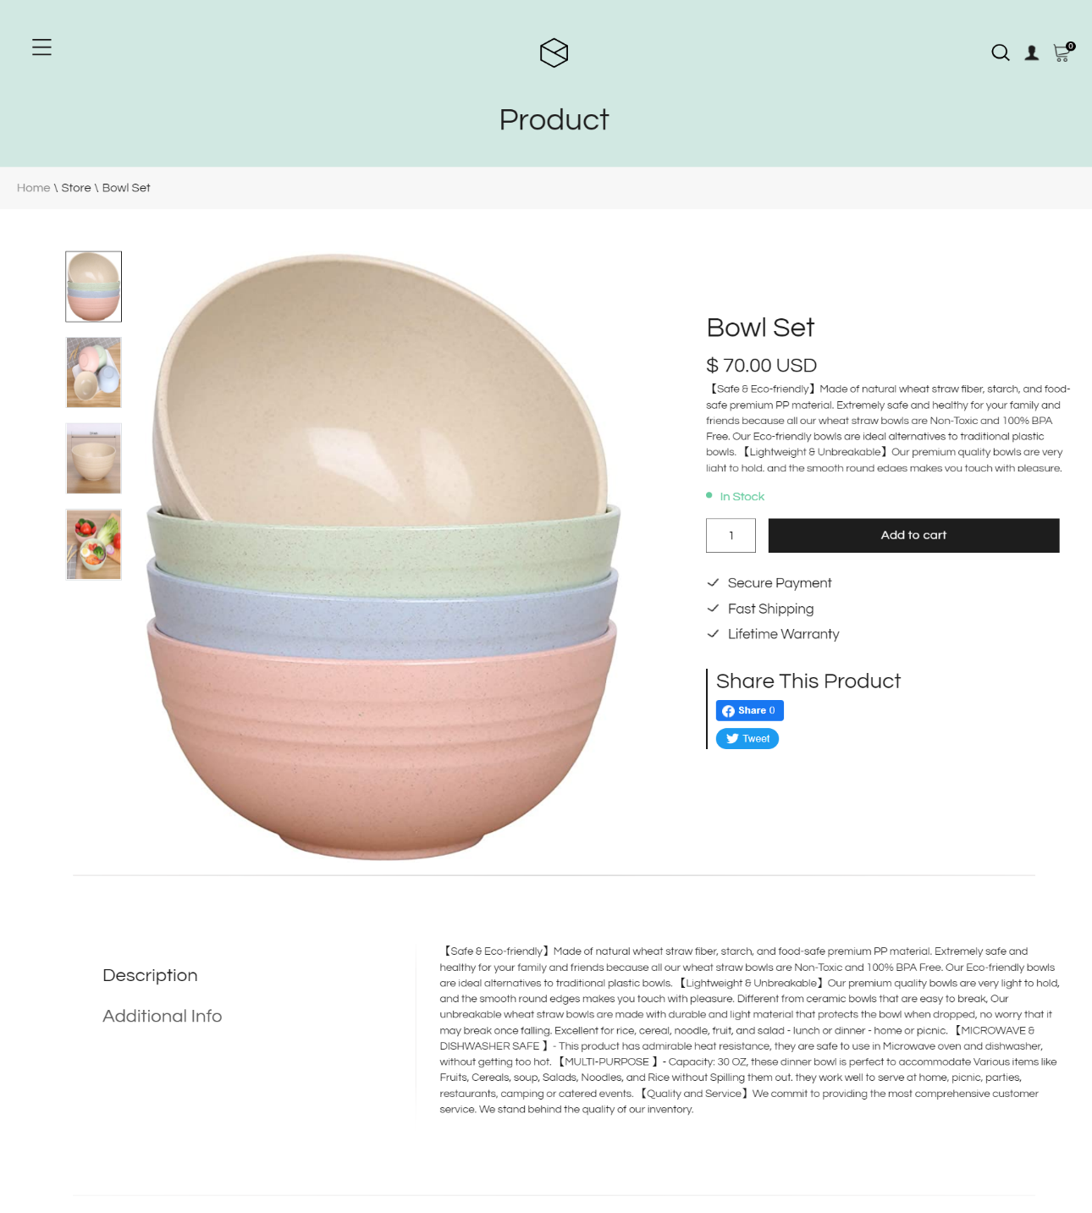

15-we also put some recommended products in this page

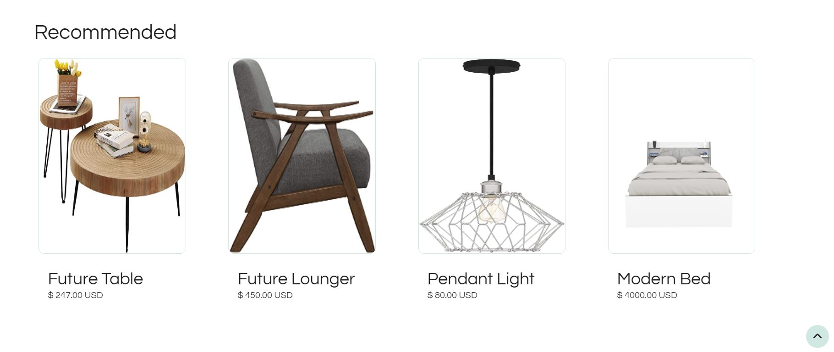

16- If the user confirms that he wants to buy the product and wants to add it to the shopping cart and presses the add to cart button, the following will happen: If the user has previously registered on the site and was at the time logged in, the product will be added to the shopping cart, but if he is not logged in, the following login page will appear.

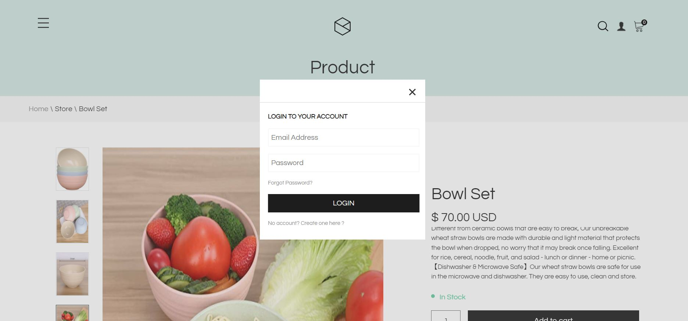

-if the user forget his password and presserd on (Forget password?) this page will appear and once the user puts his email the password will be sent to the email immediately.

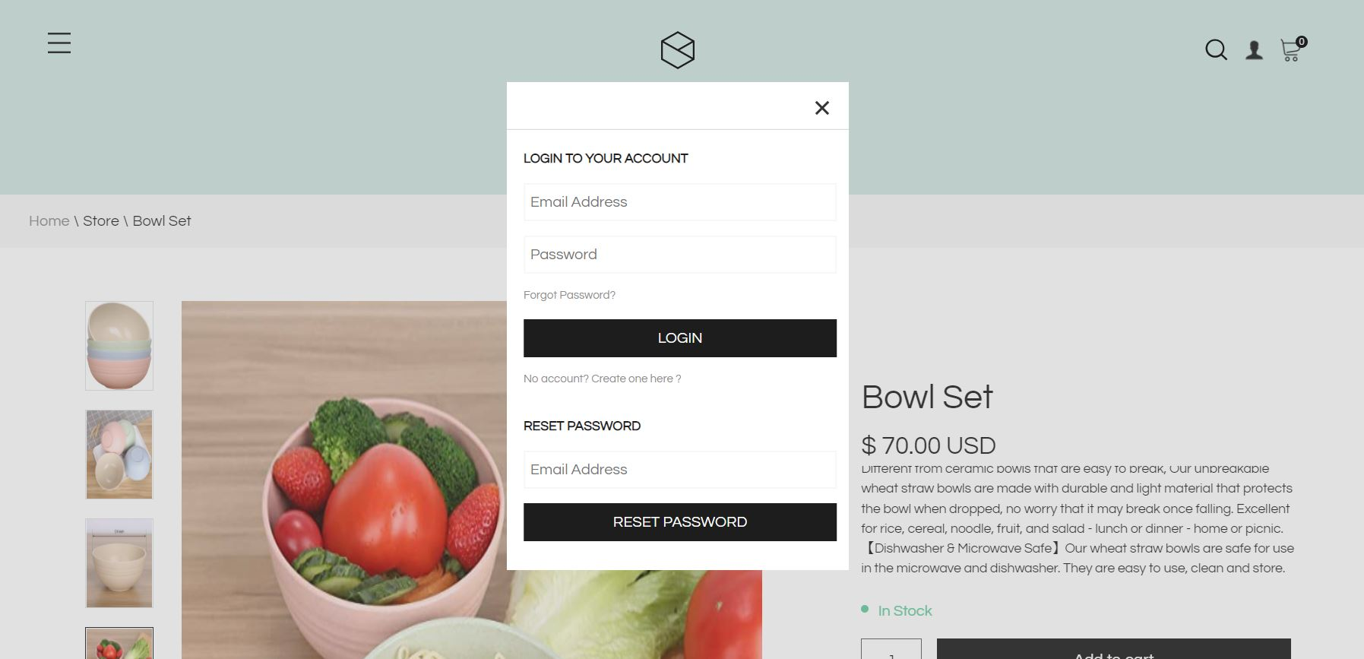

-if the user don’t have account he will press on the question (No account? Create one here?) and this page will appear

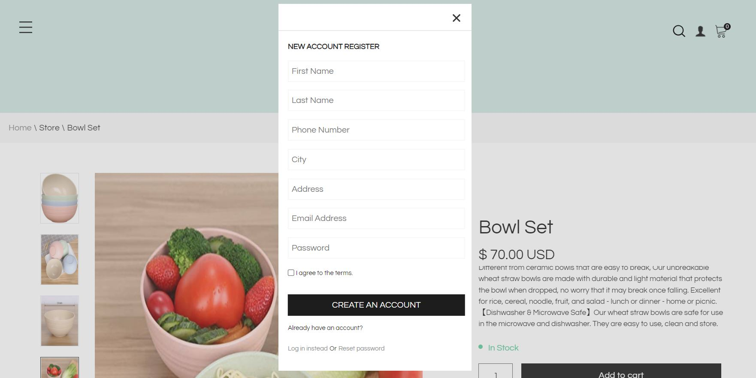

-Note:all the above pages(login,signup, forget password) could be reached from the profile button in the nav bar , but we need to clarify that once the user is logged in the site the same button becomes a profile page for the user like the image below

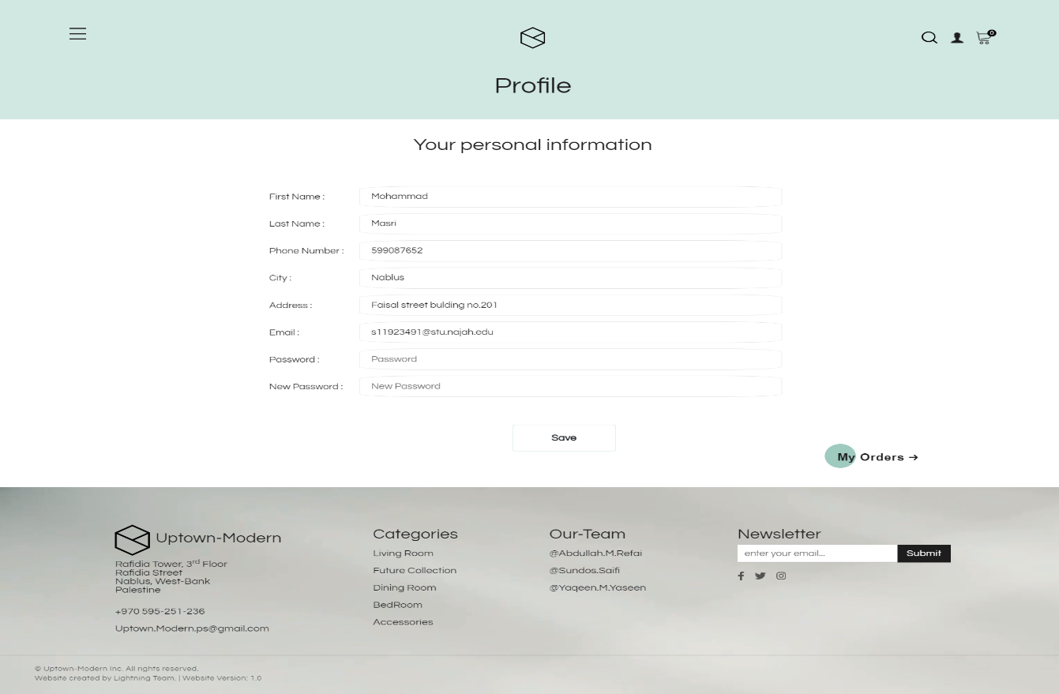

17-in the profile page we can see all the orders in this screen,we also can ask for a refund request in this page ,the request will reach us on the email and we will contact with the user by email.

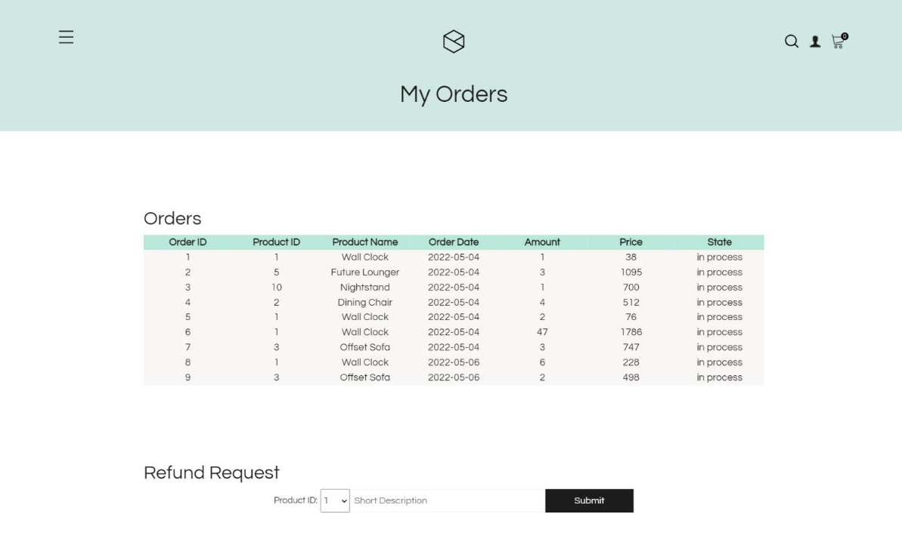

18-when the product is added to the cart the following shopping cart will appear, once we enter on the cart, in this page the user can pay for the product using paypal,and all other products that are added to cart will appear in this cart .

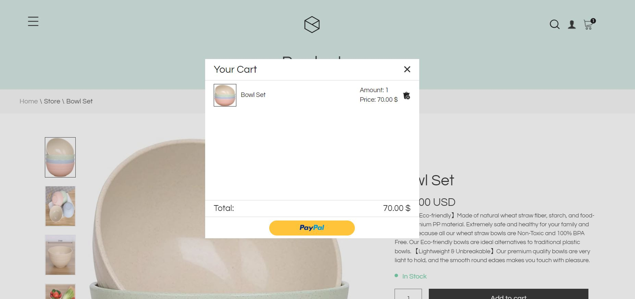

-checkout process:

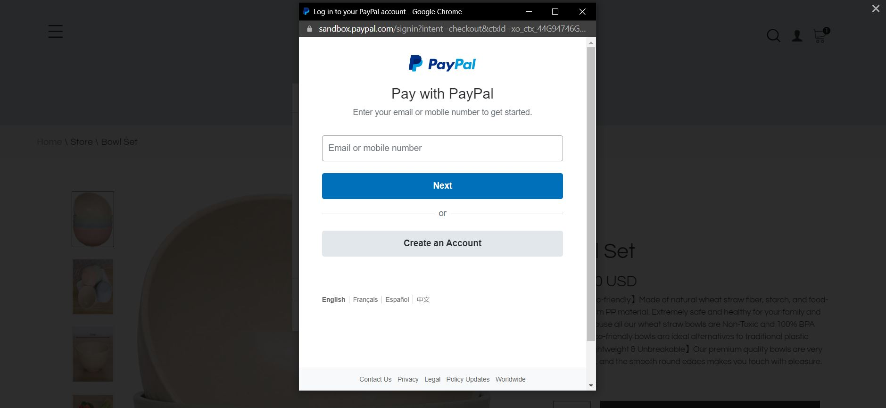

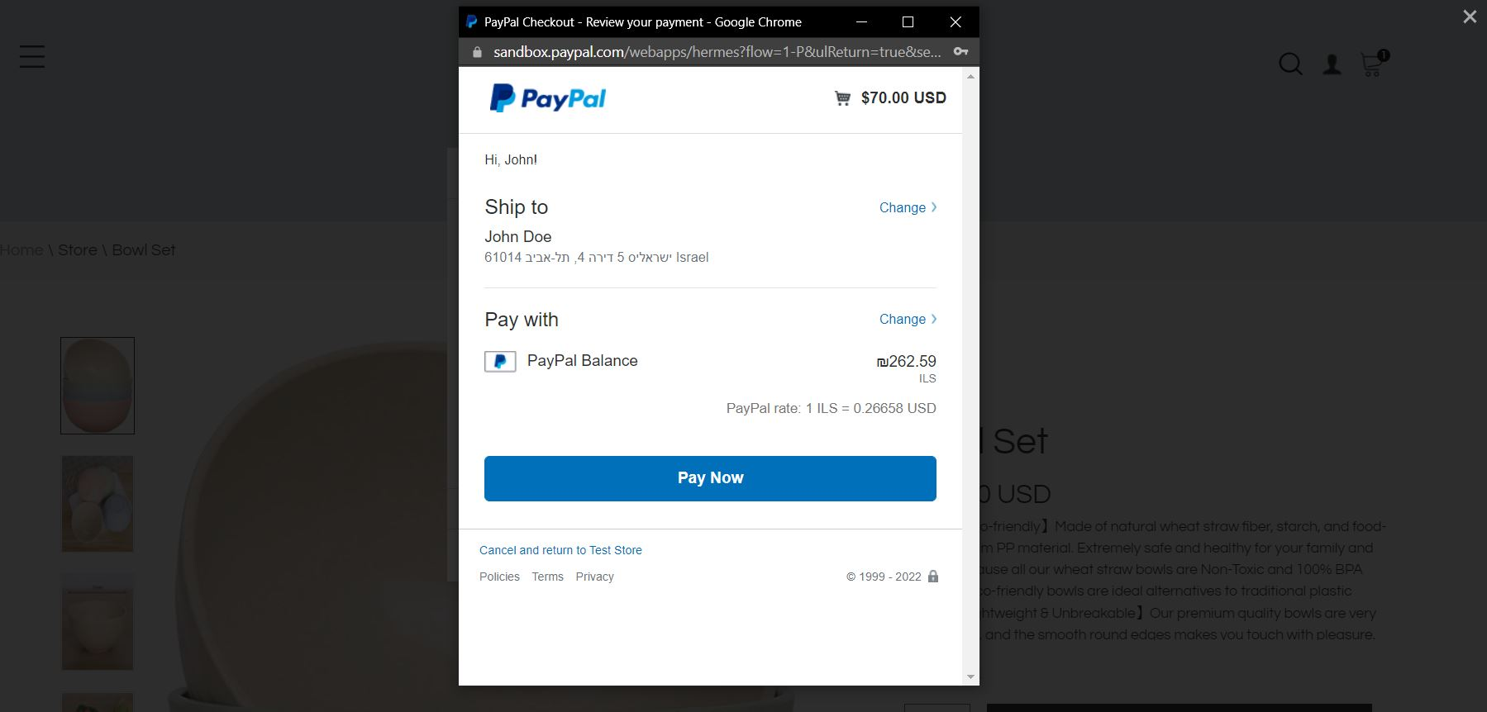

19-if we want to search about something in the project we can use the search button in the navbar and this screen will appears,in this screen what ever we write in the field the site will search for all products that has the same word.

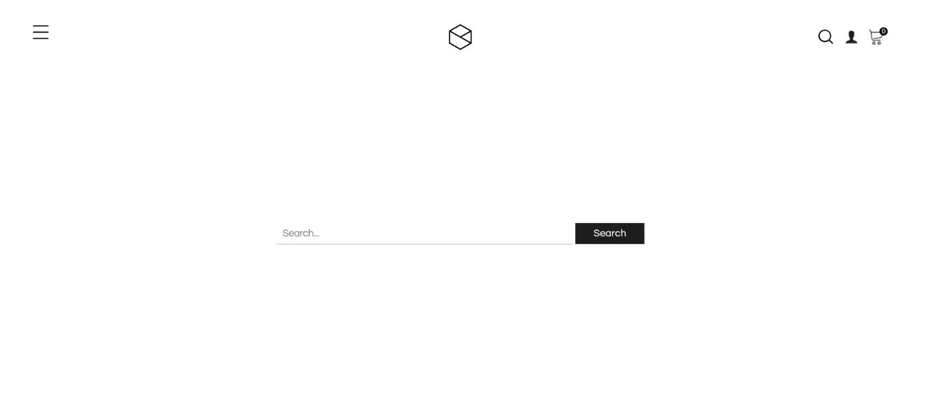

20- The blog page is a page specialized in displaying articles about furniture. It also displays tips and the latest trends in furniture. At first, when you open it, all articles of all categories appear, including tips, trends, and reviews. You can determine which articles you want through the categories on the left.

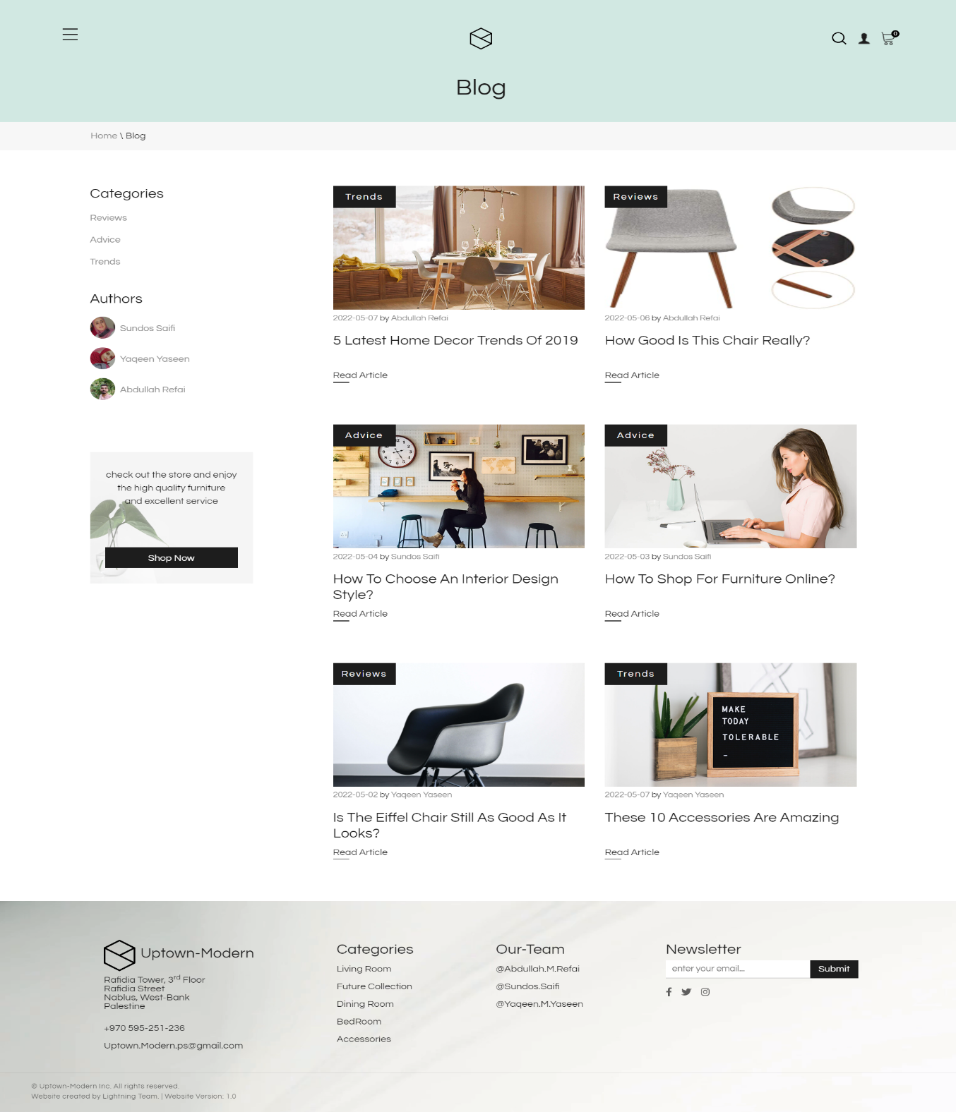

21- If you press the Read Article button, this screen will appear. On this screen, we display a large image of the product and an article about it, in which we explain in detail what we want to explain.

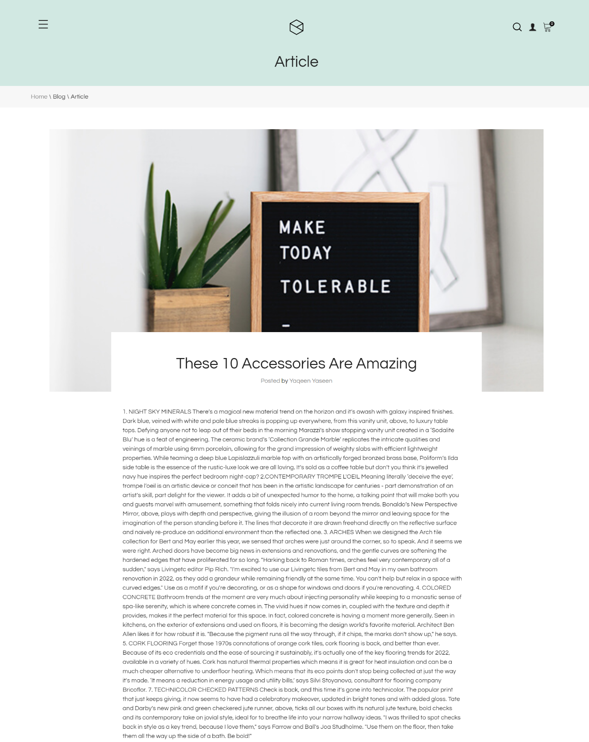

22- We also put information about the author of the article and the ability to share this article on Facebook or Twitte,and we also put latest posts .

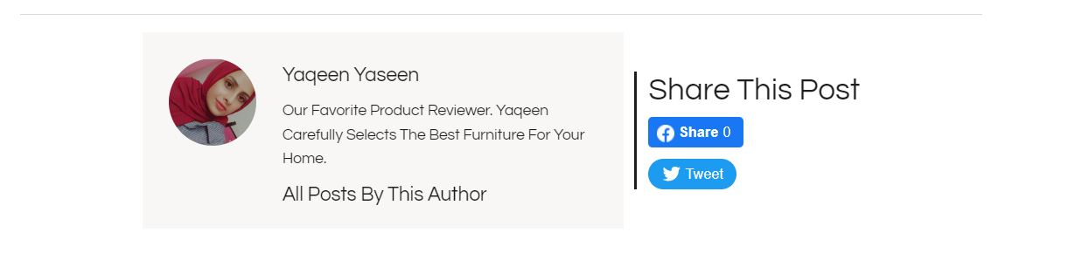

23-When you click on the contact us page, the following screen will appear, through which you can communicate with us in several ways by visiting our showroom, calling us, or emailing us by putting your name, email address and the consultation you want,we also used google maps to make it easier on you to reach us.

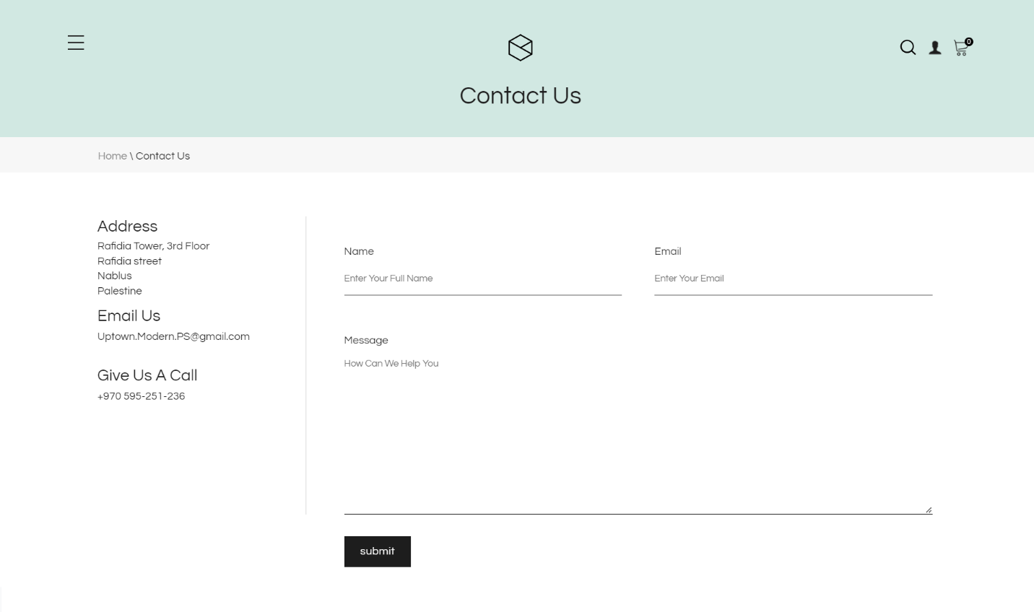

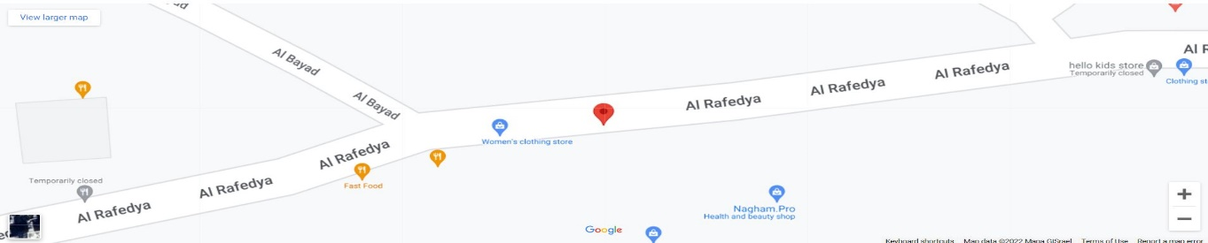

24-when the user wants to log out he can press on log out in the side nav ,and he can reach it from anywhere in the project

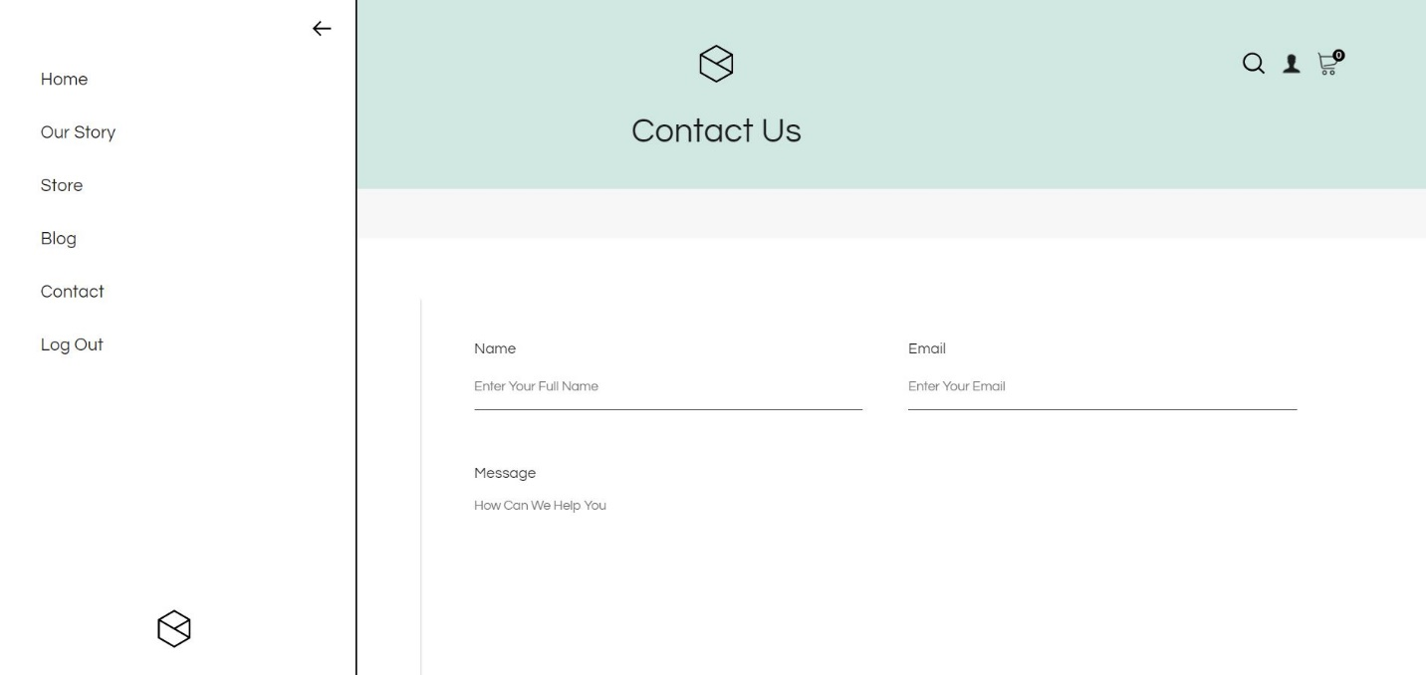

Admin:

A:Layout when logging in as a Admin:

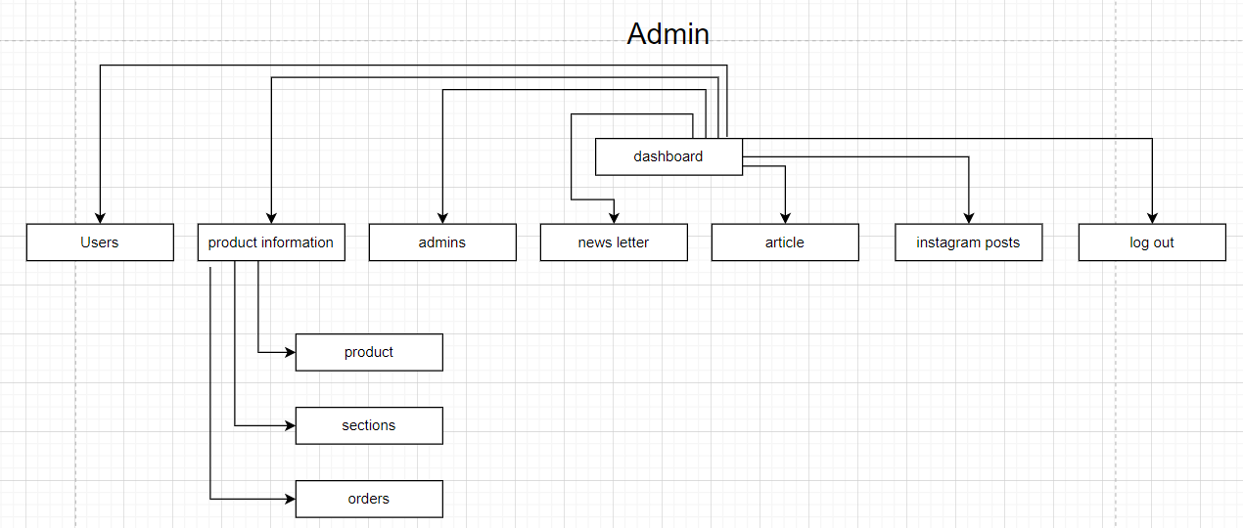

B:GUI when logging in as a Admin:

1-Users: This page displays user data with the possibility of blocking one of them in case of abuse.

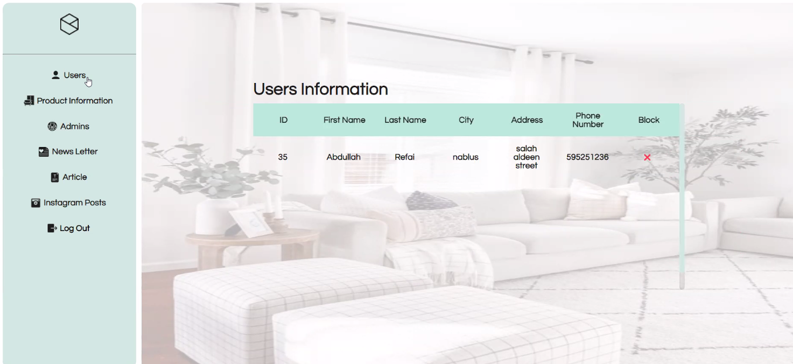

2-product information:this page displays products and adds other products with the ability to mark a product as unavailable.

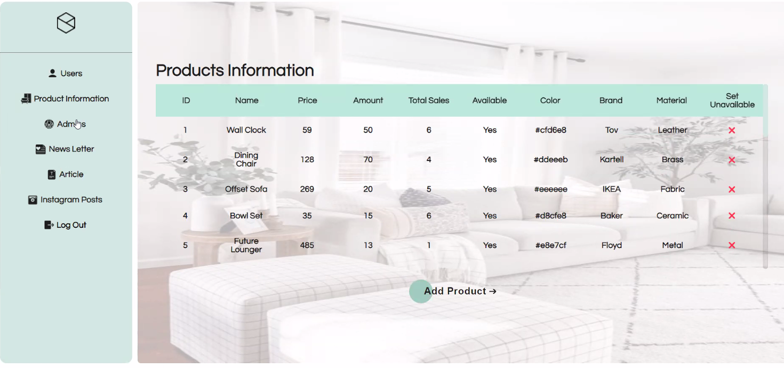

3-add product to add a new products:

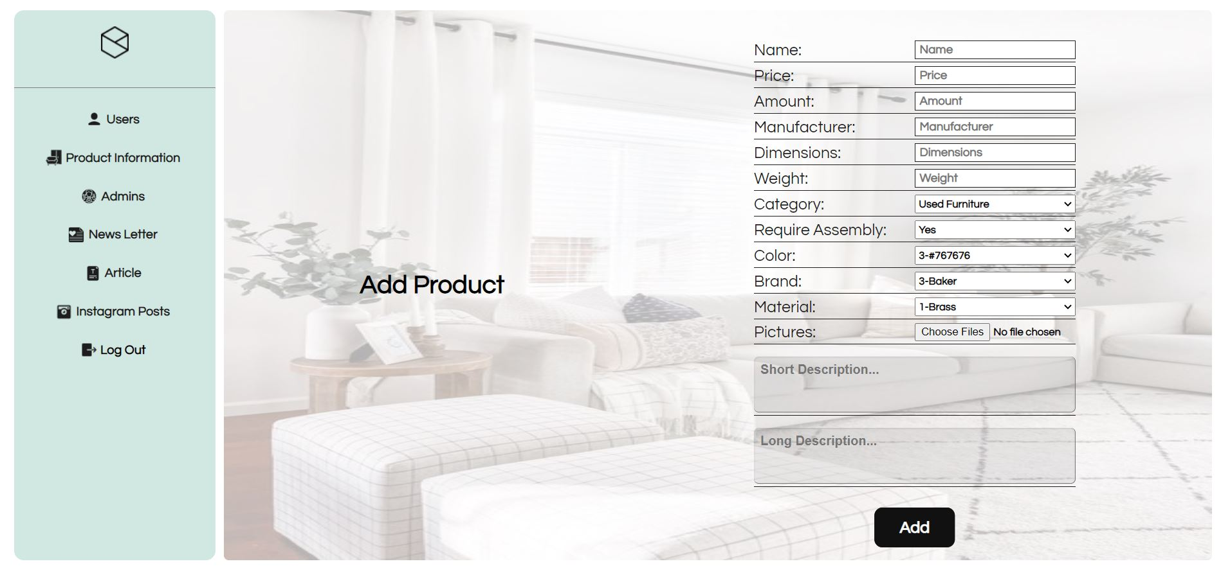

4-product sections:

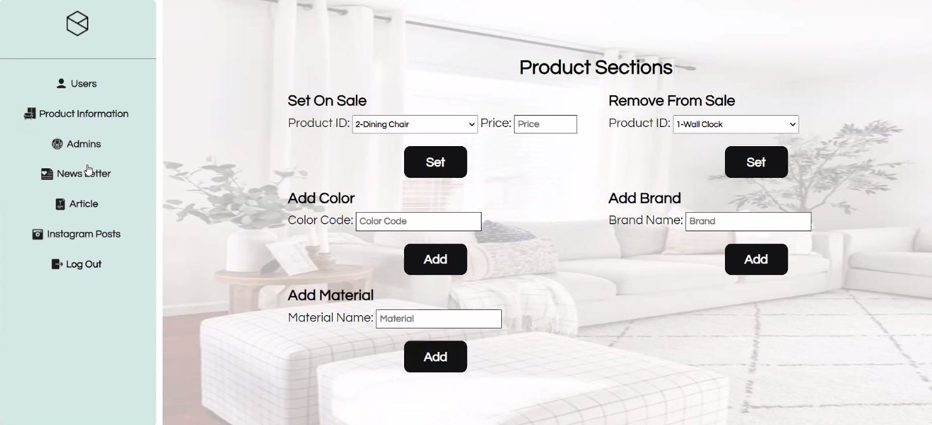

5-Orders:This page displays requests, tracks the request if it arrives or not, and determines if there is a return request and a refund

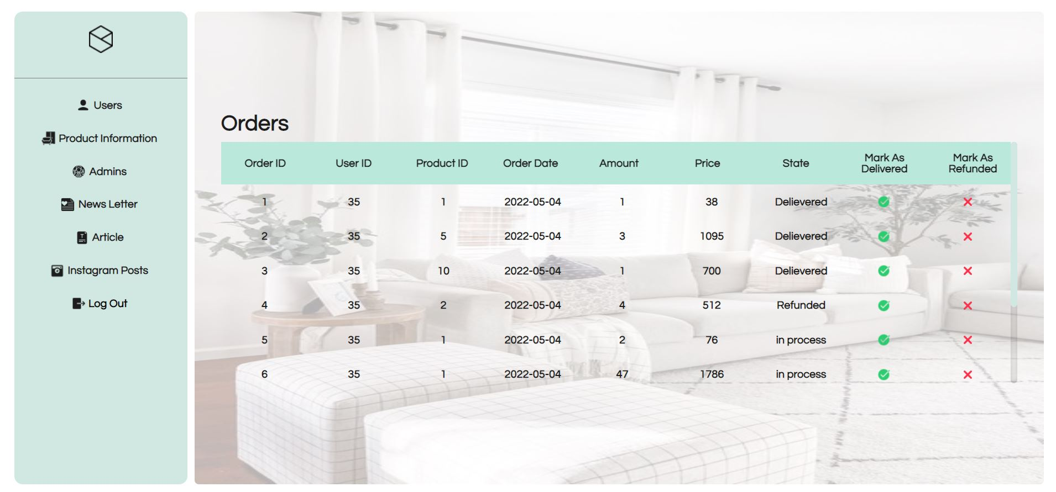

6-Admin:This page displays the dams on the site with the ability to modify their bio

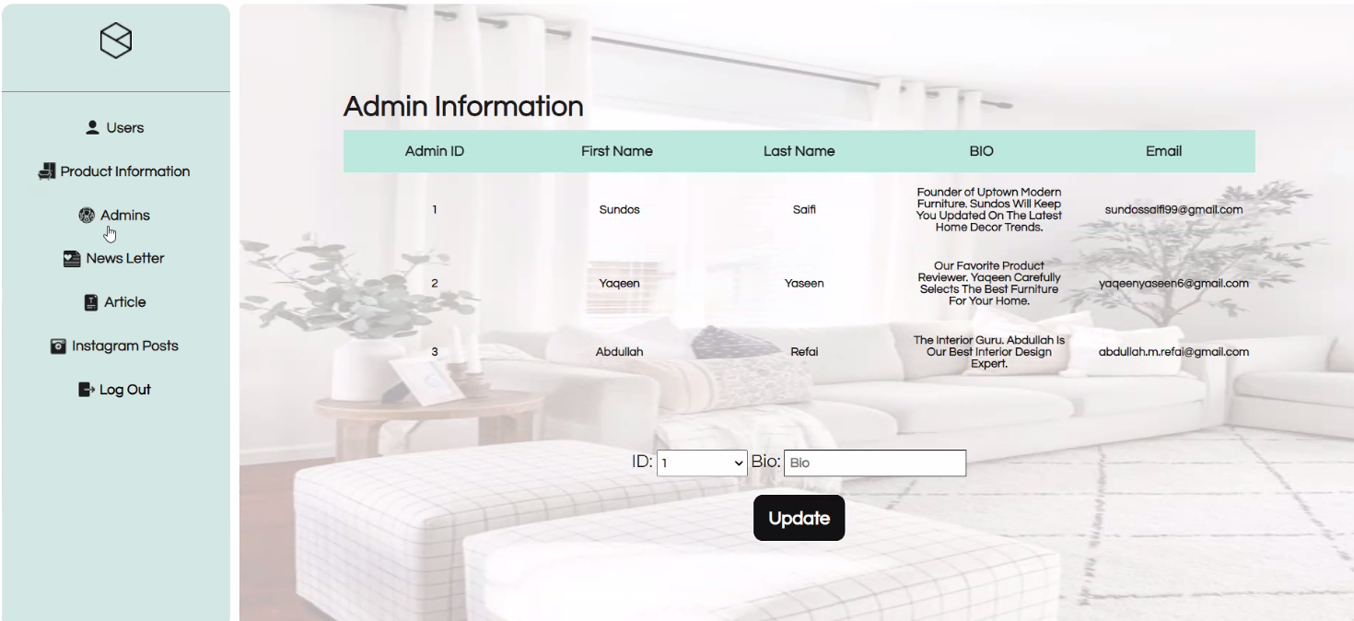

7-news letter: This page sends emails to subscribers of this feature about the latest updates in the application, new products and sales.

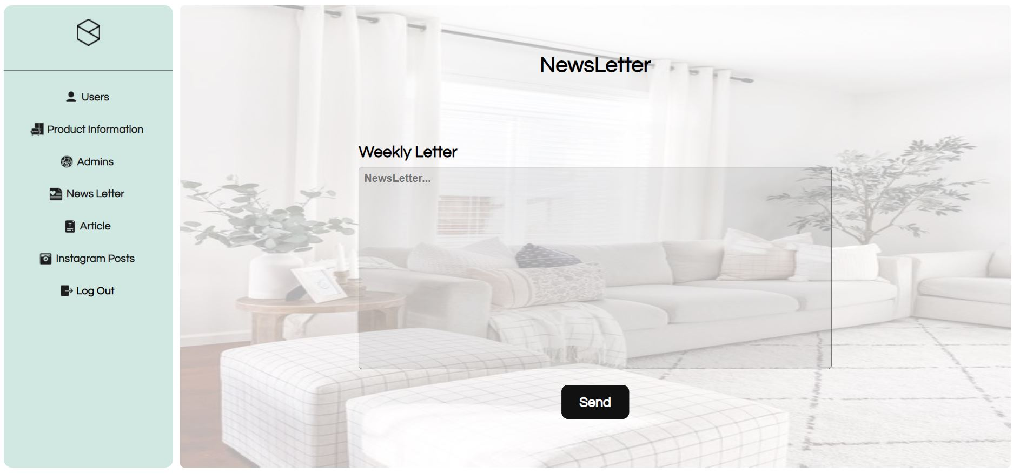

8-Article: This page displays the articles with the possibility of deleting any of them or inserting new ones

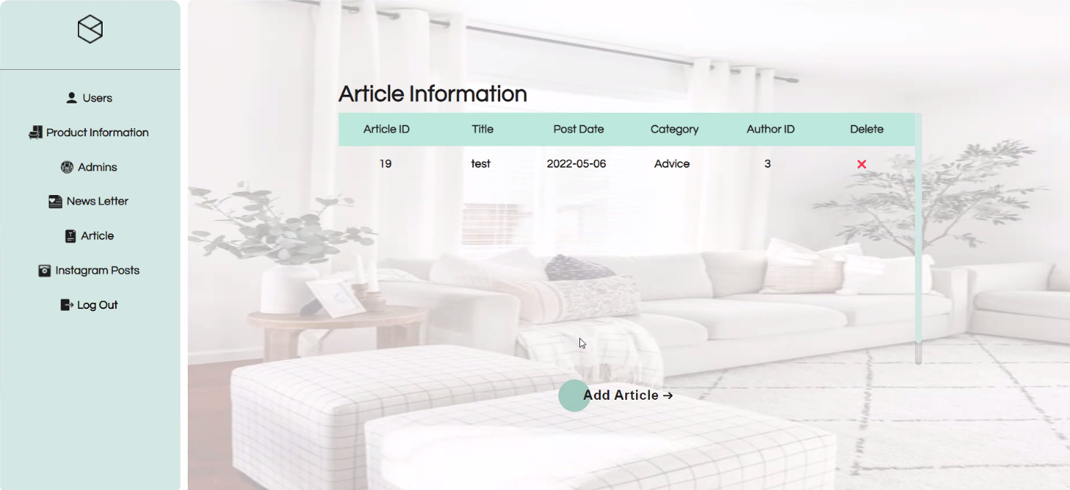

9-add article to add a new articles:

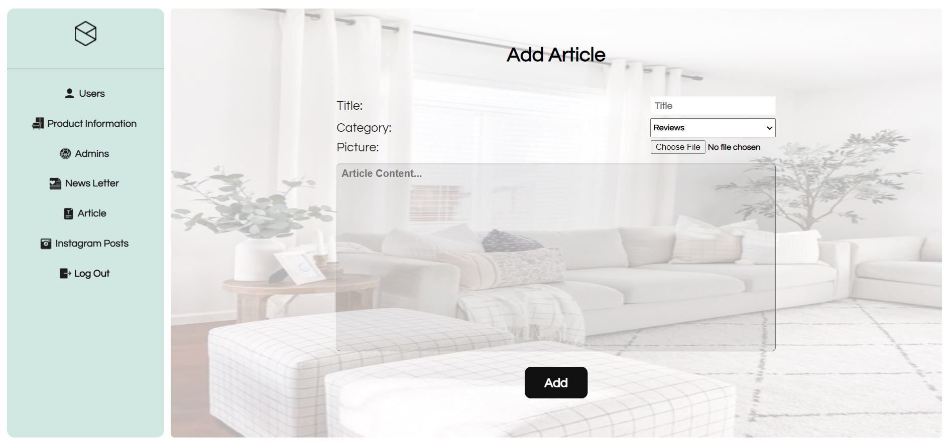

10-instagram posts: This page adds posts from Instagram and deletes existing posts

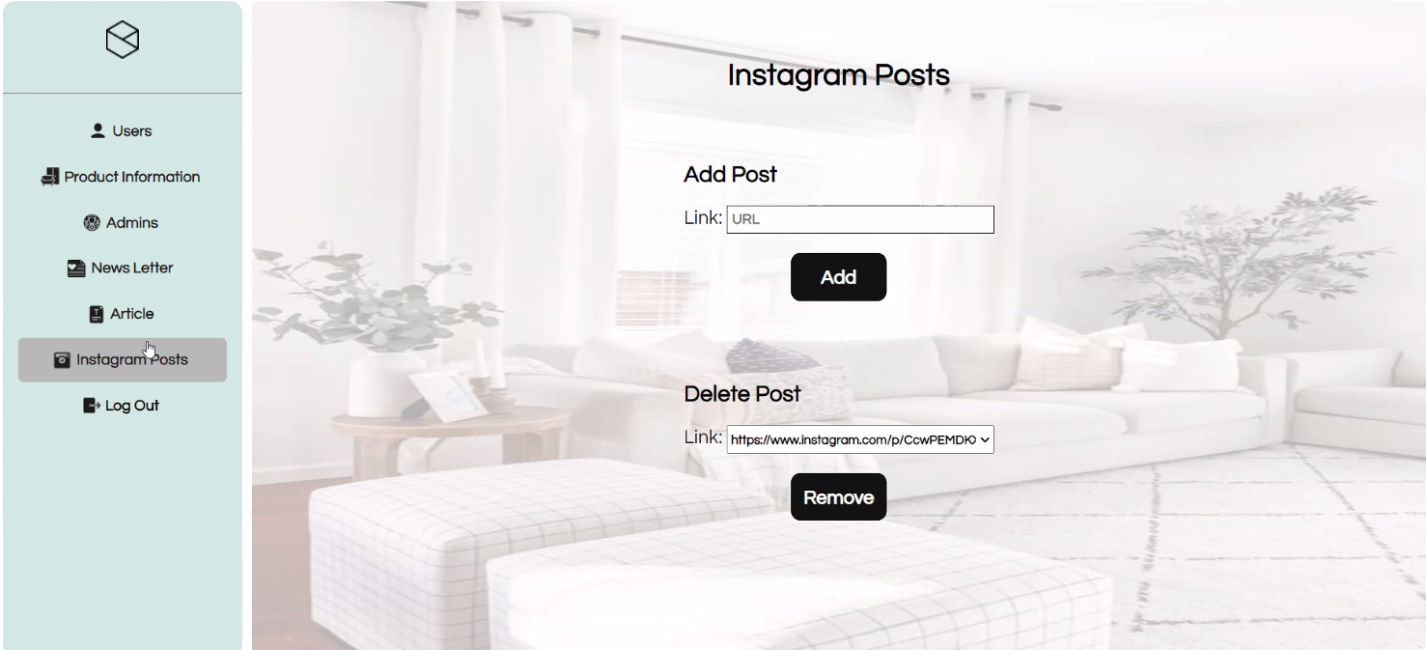

**Conclusion:**

This website helps users in shopping from there homes, also they can buy furniture and prepare their houses from home in the way they want, also its allows the owner to show what he has in his store.

**References:**

1. web programming slides by Dr.sufyan samara.

2. web programming lectures by Dr.sufyan samara.

3.w3schools: <https://www.w3schools.com/>

4.paypal developed documentation: <https://developer.paypal.com/docs/checkout/standard/integrate/>

5.facebook developer documentation: https://developers.facebook.com/docs/plugins/share-button/

6. twitter developer documentation: https://developer.twitter.com/en/docs/twitter-for-websites/tweet-button/overview

7. google iframe documentation:

<https://www.googlemapsiframegenerator.com/?gclid=CjwKCAjwjtOTBhAvEiwASG4bCMVvaQ7lKxOCGU9unBaygdnBARvS1iAZ0MfqXkHpGajuD-HATEQnDBoCLLIQAvD_BwE>

8. fontawesome:

<https://fontawesome.com/>

9. stackoverflow :

https://stackoverflow.com/